**1.Sitemap**

**2.GUI(s)**

Login Page

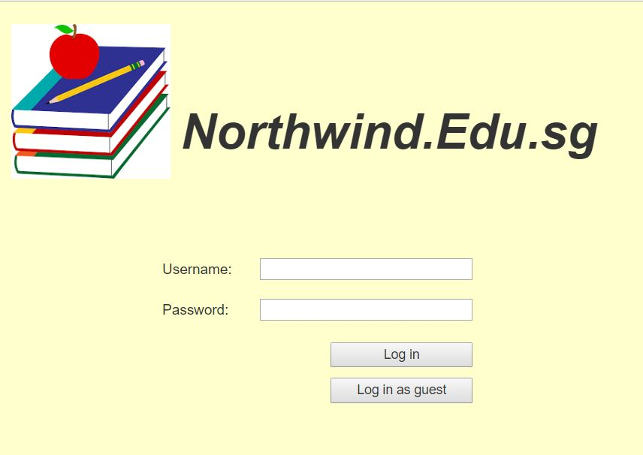

HomePage>About Us

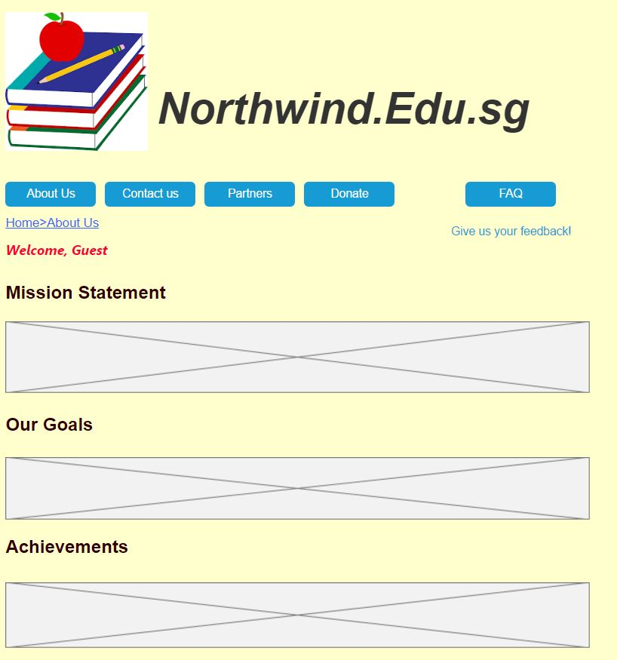

HomePage>Contact Us

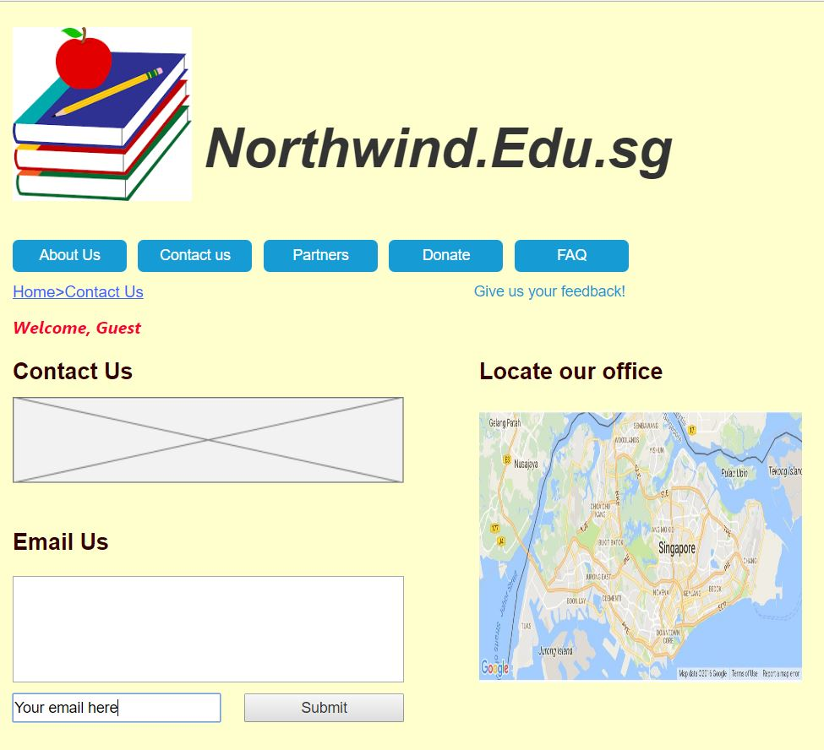

HomePage>Partners

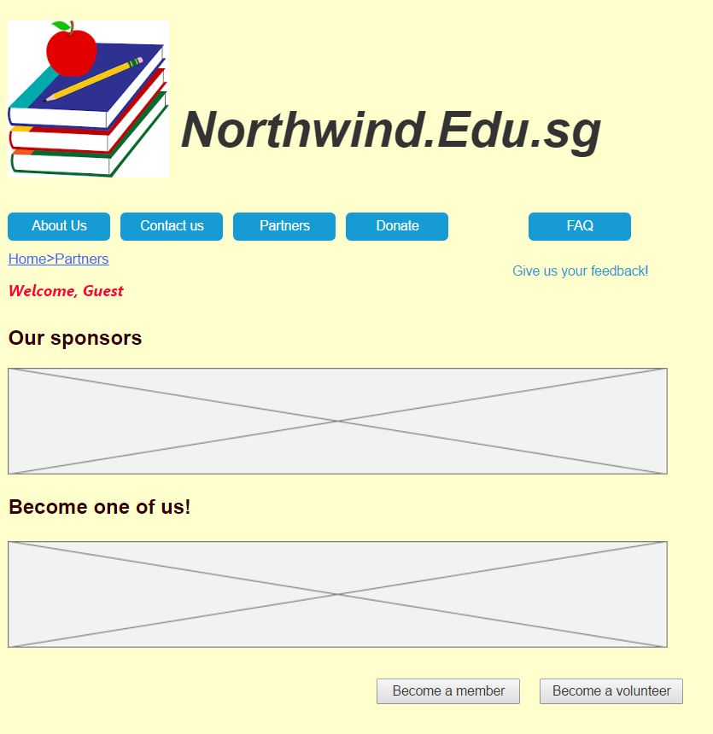

HomePage>Donate

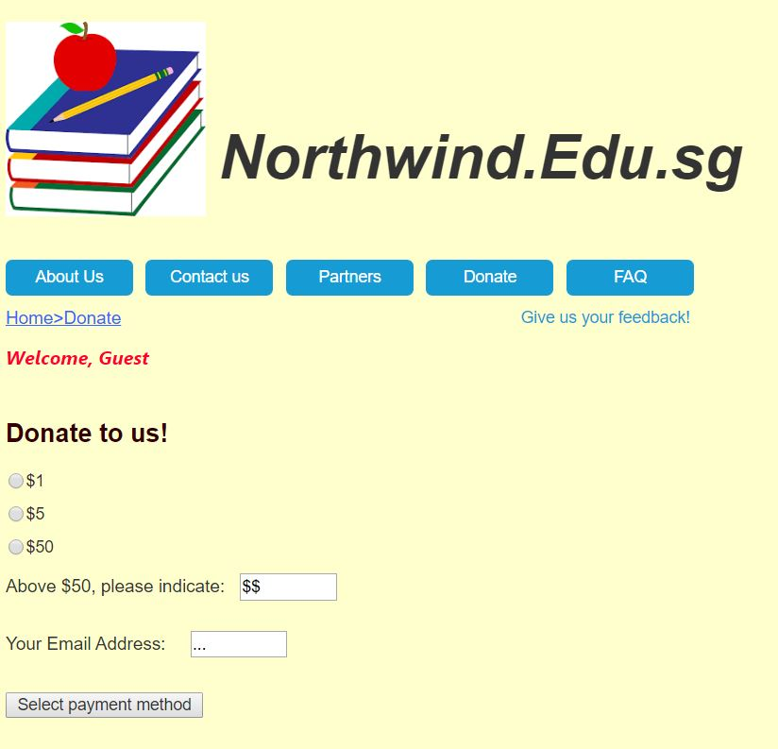

HomePage>FAQ

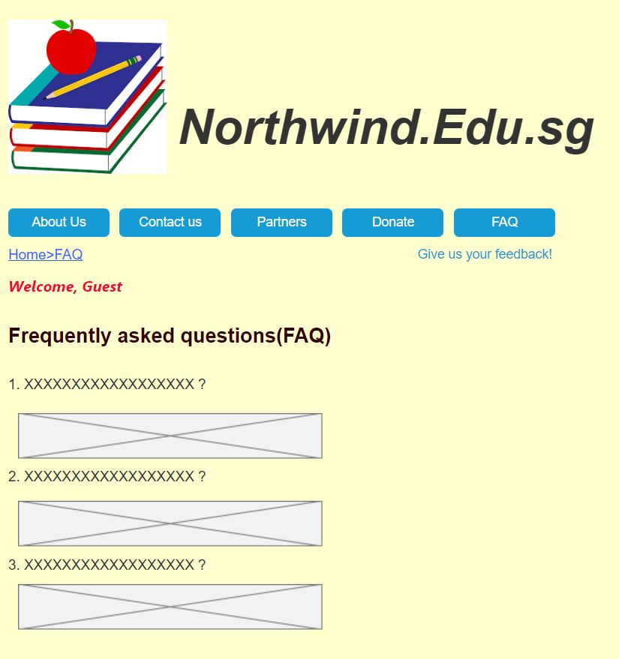

HomePage>Feedback

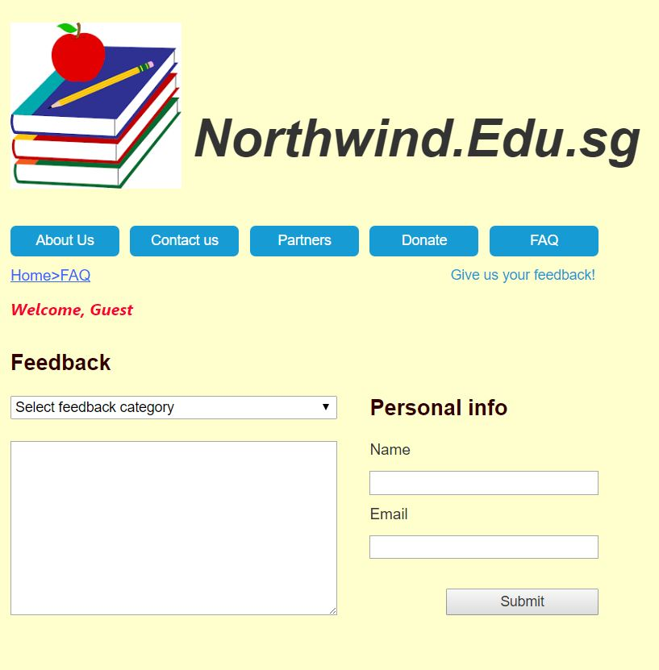

Homepage for guest

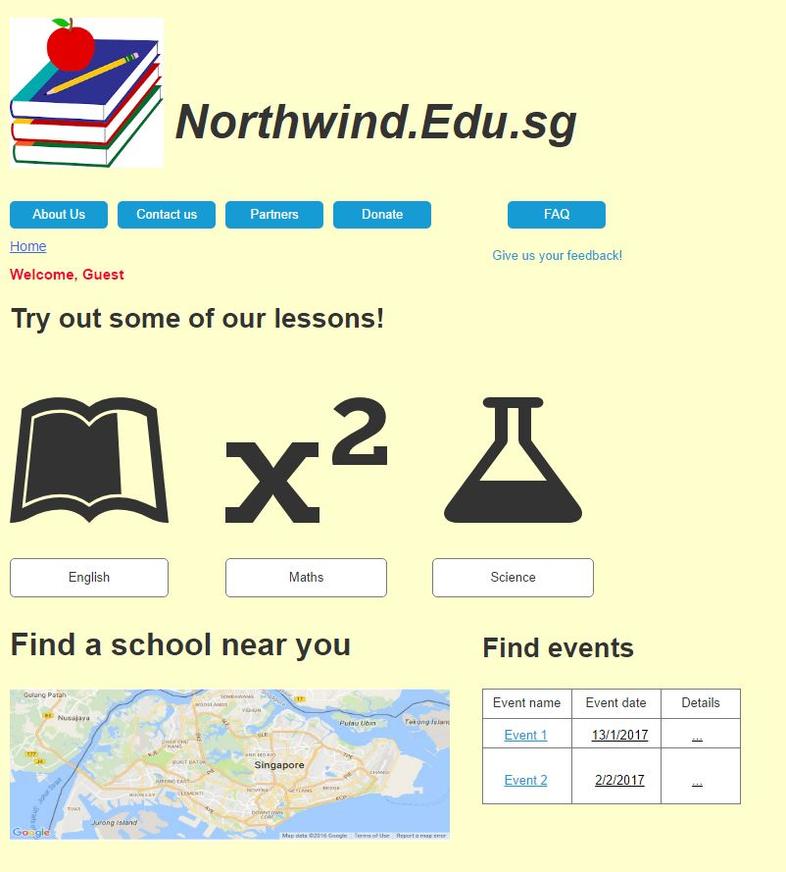

Homepage for Admin

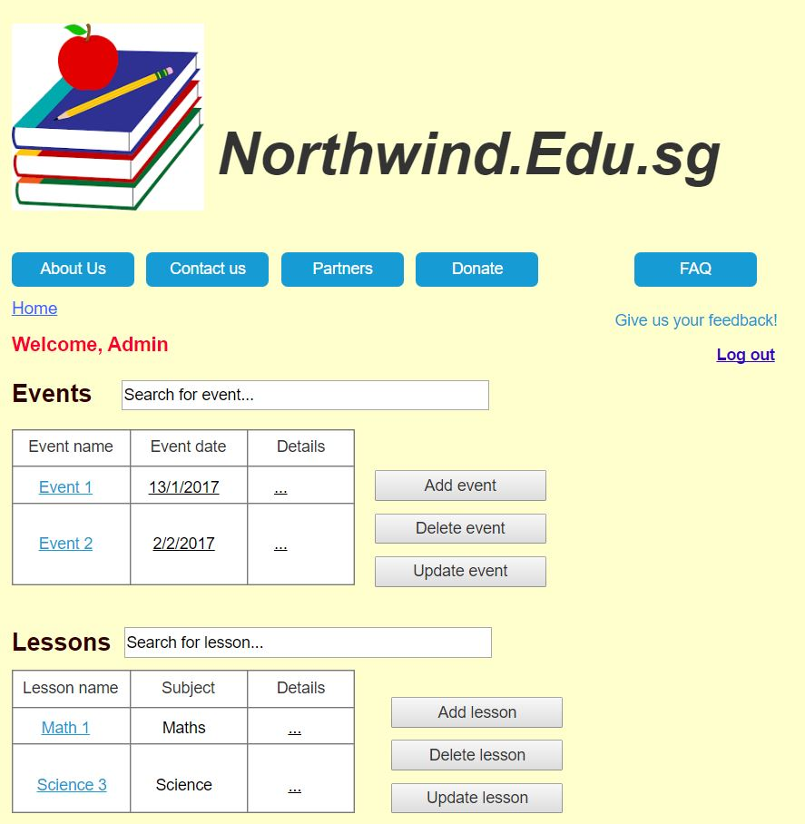

Homepage for Member

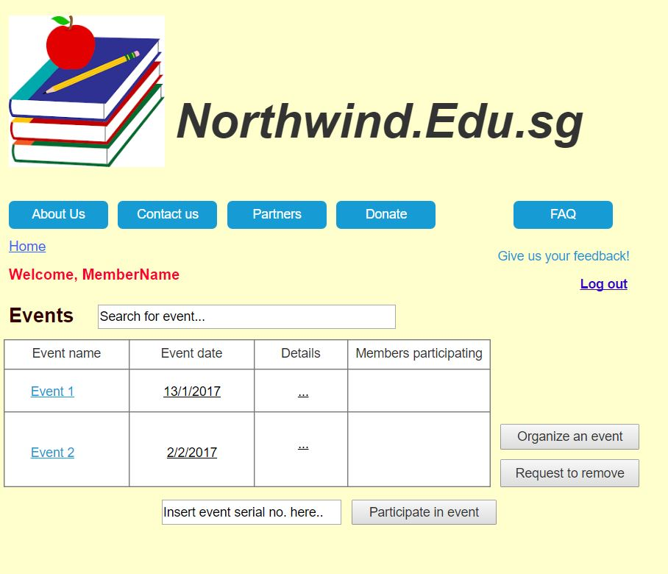

**3.Data Tables**

Users

|  |  |  |
| --- | --- | --- |
| Column | Data Type | Null? |
| Username (PK) | Varchar(25) | No |
| Password | Varchar(25) | No |
| Access Level | Int | No |

Events

|  |  |  |
| --- | --- | --- |
| Column | Data Type | Null? |
| Event ID (PK) | Varchar(6) | No |
| Event Name | Varchar(30) | No |
| Event Date | Date | No |
| No. of Participants | Int | No |
| Location | Varchar(50) | No |
| Details | Varchar(100) | Yes |
| Organizer ID(FK) | Varchar(10) | No |

Organizers

|  |  |  |
| --- | --- | --- |
| Column | Data Type | Null? |
| Organizer ID(PK) | Varchar(20) | No |
| Organizer | Varchar(25) | No |
| Company | Varchar(30) | No |

Schools

|  |  |  |
| --- | --- | --- |
| Column | Data Type | Null? |
| School ID(PK) | Varchar(20) | No |
| School Name | Varchar(25) | No |
| School Location | Varchar(60) | No |
| Website | Varchar(60) | No |

Courses

|  |  |  |
| --- | --- | --- |
| Column | Data Type | Null? |
| Course ID (PK) | Varchar(25) | No |
| Course Name | Varchar(25) | No |
| Course Detail | Varchar(100) | No |
| Location | Varchar(30) | No |

**3.Task Distribution**

Conceptual Design  
-Sitemap (Hong Wei)  
-GUI (Hong Wei)  
-Tables (Abdul Hakiim)